**Project Design Phase-II**

**Technology Stack (Architecture & Stack)**

|  |  |
| --- | --- |
| Date | 12 April 2025 |
| Team ID | SWTID1742751842 |
| Project Name | ShopEZ: One-Stop Shop for Online Purchases |
| Maximum Marks | 4 Marks |

**Technical Architecture:**

The system architecture of **ShopEZ**, an online e-commerce platform, is designed to ensure a seamless, scalable, and secure user experience for both customers and administrators.

At the core of the platform lies the **cloud-based infrastructure**, which hosts the **Frontend**, **Databases**, and **Payment Services**.

**Customers** interact with the system through the **Web App**, where they can browse products, manage their cart, and complete purchases. This interface is powered by the **Frontend**, which communicates with the **cloud database** to retrieve real-time product information, user data, and order history.

To ensure secure financial transactions, the frontend is integrated with third-party **Payment Services** that handle tasks like card processing, EMI options, and confirmation of successful transactions.

On the administrative side, **Admins** access the **Admin Panel** to oversee backend operations. They can manage product listings, update order statuses, handle user support queries, and monitor payment issues. This panel connects directly with the payment services and database to maintain synchronization between user activity and internal operations.

Overall, this architecture supports real-time data exchange, fast performance, and modular service integration, providing a robust foundation for ShopEZ’s digital commerce ecosystem.

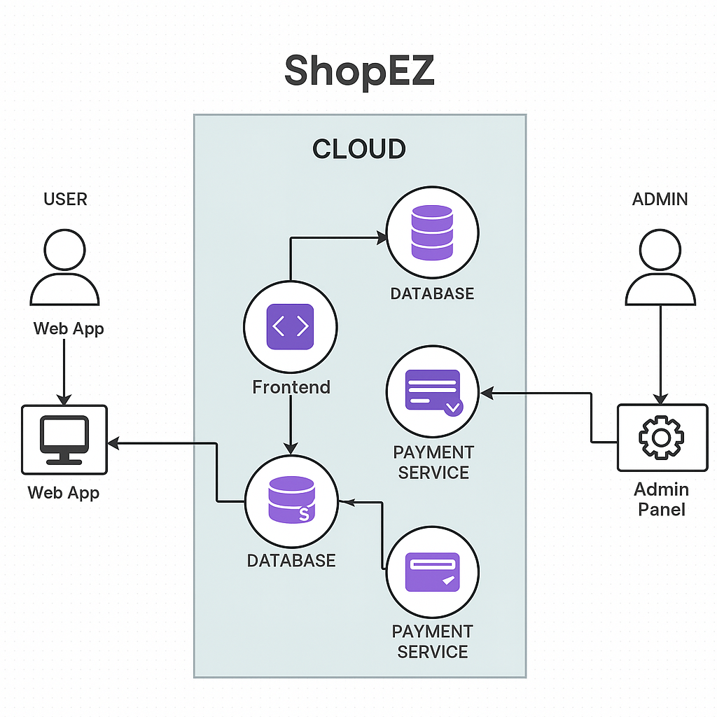

**Components & Technologies:**

|  |  |  |  |
| --- | --- | --- | --- |
| **S.No.** | **Component** | **Description** | **Technology** |
| **1** | User Interface | Web UI where users browse products, register/login, checkout | HTML, CSS, JavaScript, React.js |
| **2** | Application Logic-1 | Handles authentication, product search, add to cart, order logic | Node.js, Express.js |
| 3 | Application Logic-2 | Session management and cart logic | Express-session, JWT |
| **4** | Database | Stores users, products, orders, and cart data | MongoDB |
| **5** | File Storage | Storing product images | Local filesystem (uploads folder) |
| **6** | External API-1 | Payment gateway for order checkout | Razorpay / Paytm API |
| **7** | Infrastructure | Hosting platform | Render / Vercel for frontend, Railway for backend |

**Application Characteristics:**

|  |  |  |  |
| --- | --- | --- | --- |
| **S.No.** | **Characteristics** | **Description** | **Technology** |
| **1** | Open-Source Frameworks | Frontend & backend built using open-source tech | React.js, Node.js, Express.js, MongoDB |
| **2** | Security Implementations | Password hashing, JWT-based authentication, HTTPS | bcrypt.js, JWT, Helmet.js, HTTPS |
| **3** | Scalable Architecture | Modular code with scalable database and REST APIs | 3-tier architecture with RESTful services |
| **4** | Availability | Deployment on reliable cloud platforms with downtime minimization | Railway, Vercel, MongoDB Atlas |
| **5** | Performance | Fast-loading frontend with optimized queries, CDN for static assets | Lazy loading, MongoDB indexing, Cloudflare CDN |